|  |  |  |  |  |  |
| --- | --- | --- | --- | --- | --- |
| Name: | ___________________________________________ | | | | Date:*__________* |
| Description: pact jpg1 | **Maths Specialist Unit 2 -** Investigation 5 – 2015  **Complex Numbers and Transformations**  In-class investigation | | | | / 42  -------- % |
| **Important Information:**  *Although the take-home component is not worth any marks, it is essential in preparation for the in-class component. Knowledge and skills gained will be extended in the in-class validation component. This in-class validation will be completed under test conditions on the day in which this take-home component is due. The take-home component may be used when completing the in-class component. Contact may be made to parent(s) if the take-home component is not available for submission (at the start of the lesson).* | | | | | |
| **Date out:** | | *Week ____ Date __________* | **Date Due:** | *Week ____ Date _________* | |
| **Take home component weighting:** | | *0% of the year* | **In-class component weighting:** | *7% of the year.* | |
| **AIM:** *In this assessment, you will be investigating* ***Complex Numbers and Transformations*** | | | | | |

**Complex Numbers and Transformations Name: ……………………………….**

In this task students will consider a set of points, in the *z*-plane and their transformation onto a set of image points** and, in the *w*-plane.

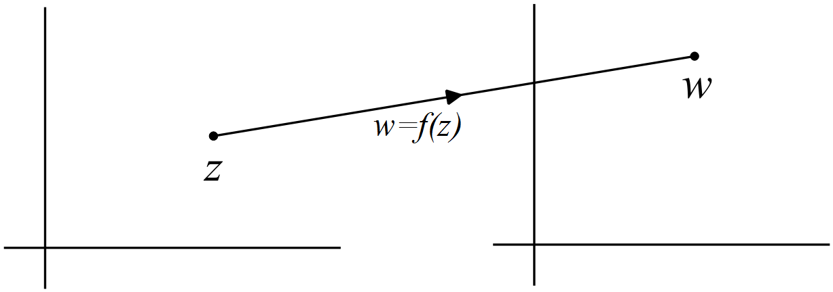

*z*-plane *w*-plane

The vertices of triangle *ABC* in the *z*-plane are given by:

.

**Question 1 (9 marks)**

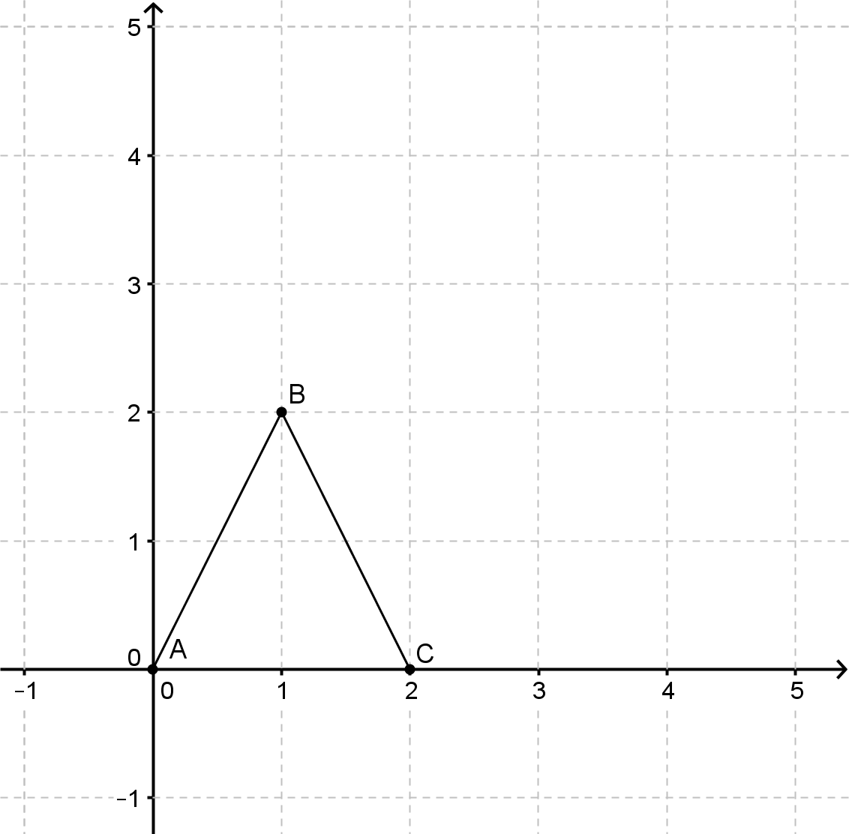 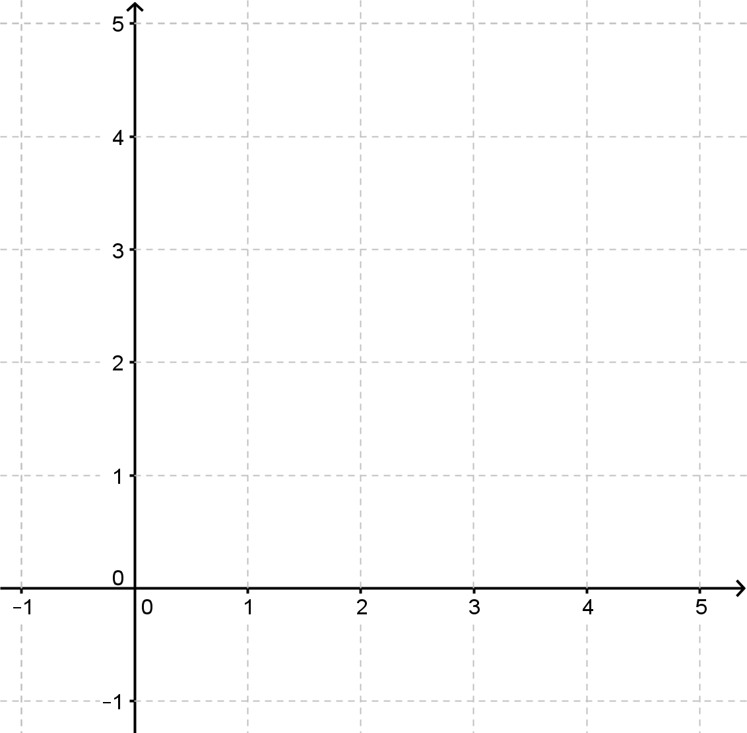

*z*-plane *w*-plane

(a) Using, determine the images** and, of each of the three vertices, and plot them on the *w*-plane above. (2)

(b) Using, determine the images** and, of each of the three vertices, and plot them on the *w*-plane above. (2)

(c) Use the axes below to investigate the transformation $f\left(\text{z}\right)\text{= z + }\left(\text{a + bi }\right)\text{, a, b ∈}$ ℝ

.

(3)

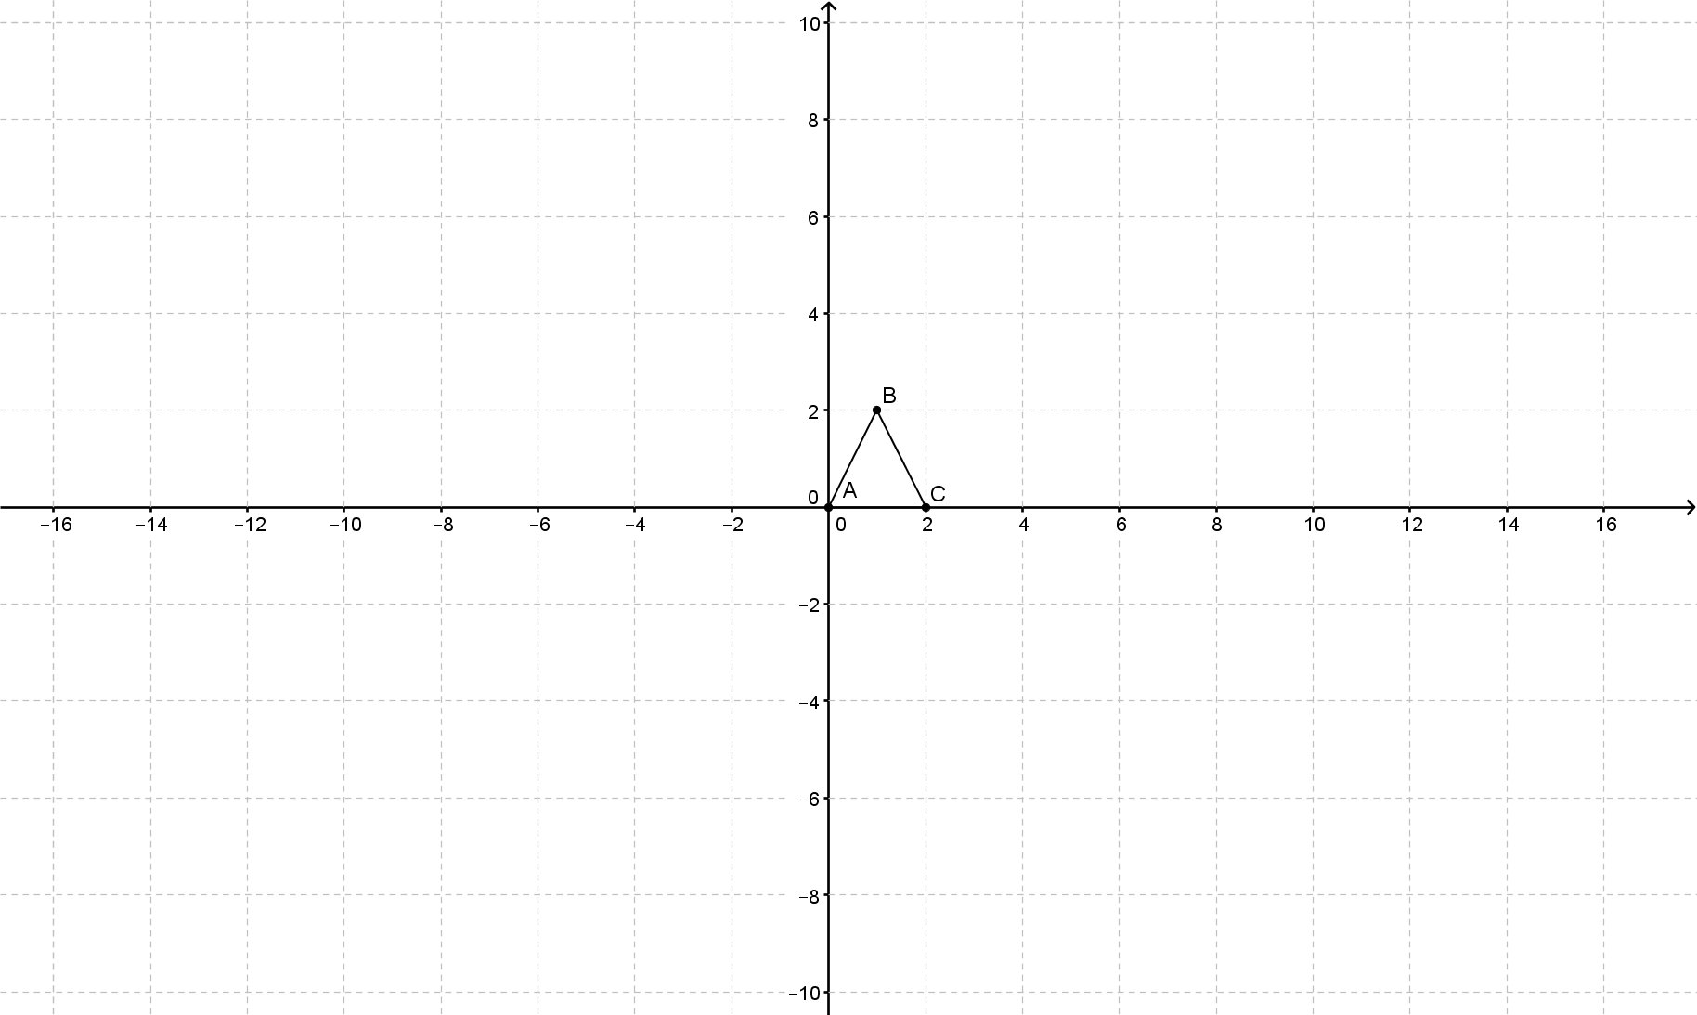

(d) Describe the transformation $f\left(\text{z}\right)\text{= z + }\left(\text{a + bi }\right)\text{, a, b ∈}$ ℝ. (2)



*z*-plane

**Question 2 (8 marks)**

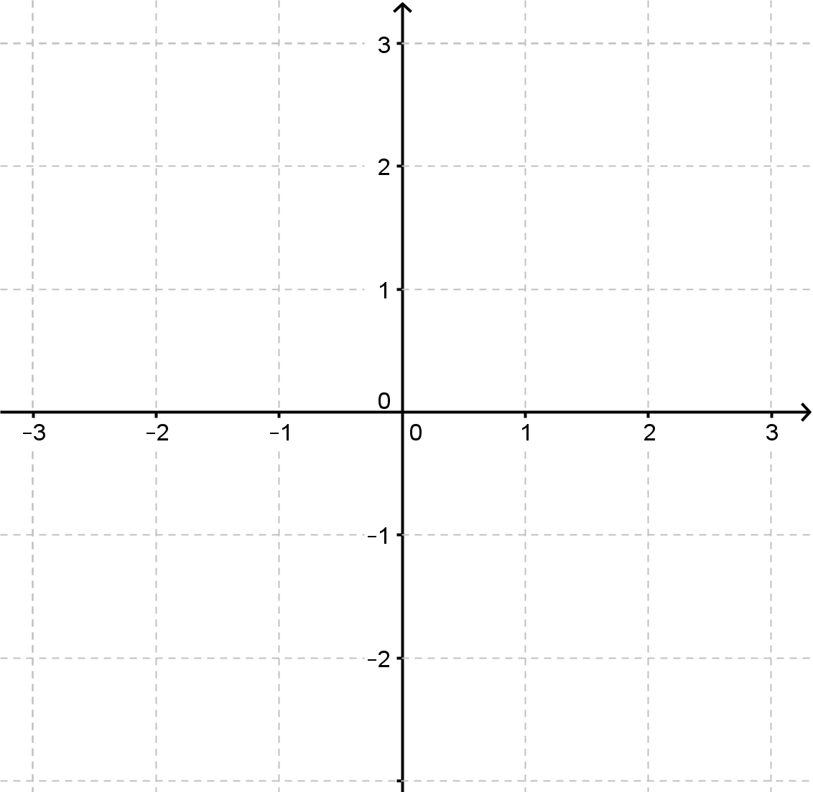

*w*-plane

(a) Using , determine the image of each of the three vertices, ** and , and plot them on the *w*-plane above. (2)

(b) Describe the transformation . (1)

(c) Definethat will result in triangle *ABC* being reflected in the vertical axis.

(1)

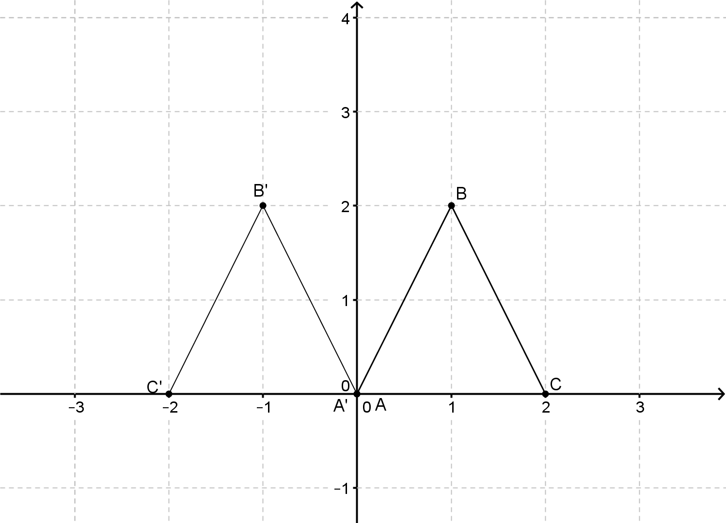

(d) Definethat will result in triangle *ABC* being reflected in the line . (2)

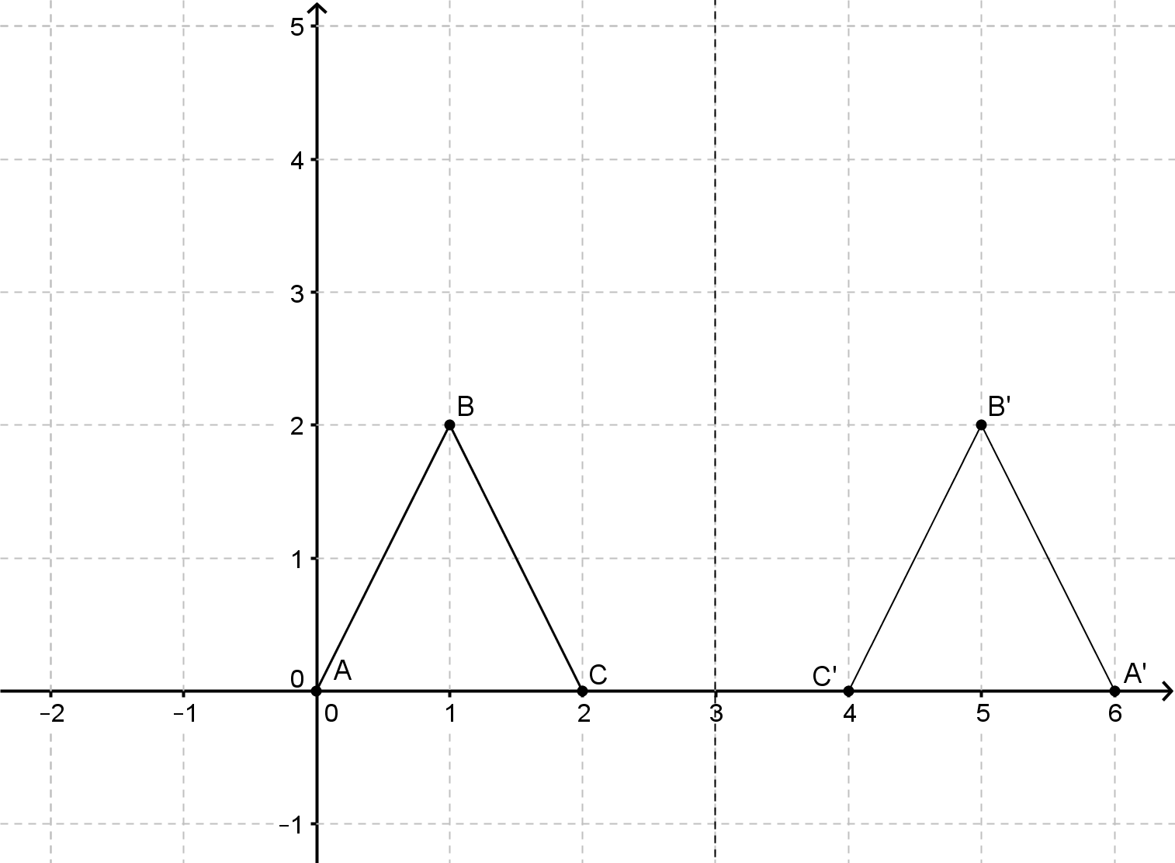

(e) Definethat will result in triangle *ABC* being reflected in the line . (2)

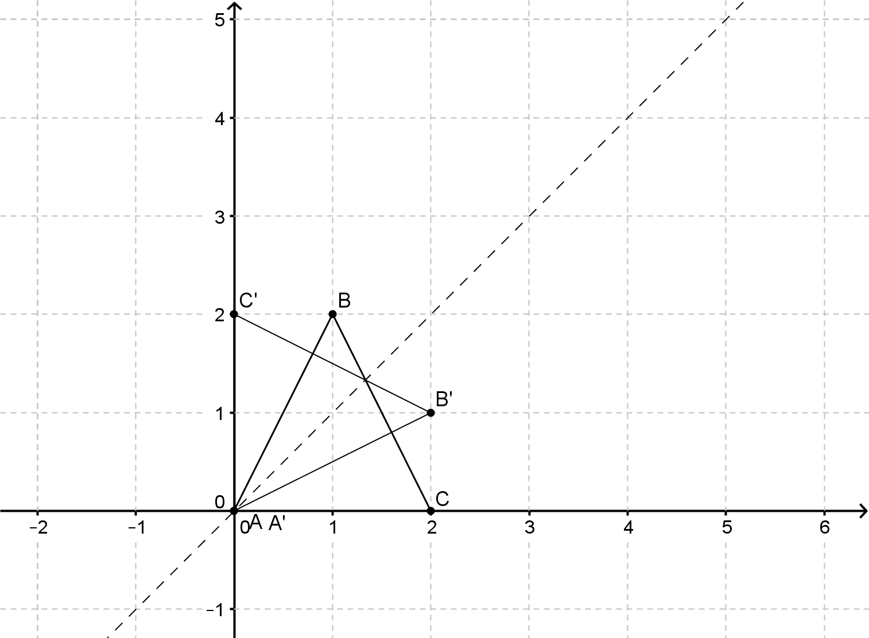



*z*-plane

**Question 3 (3 marks)**

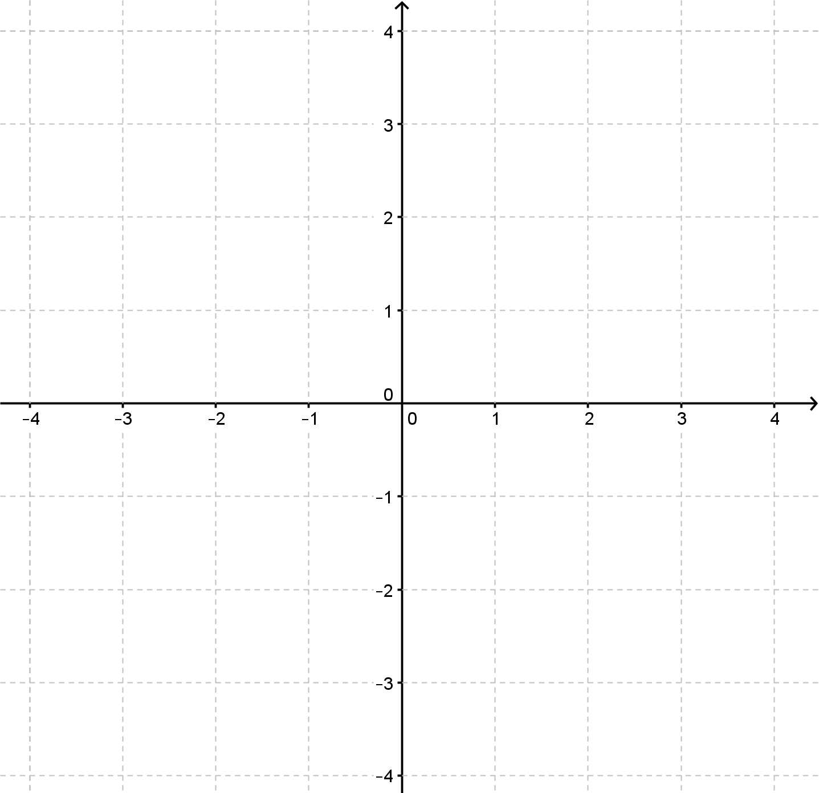

*w*-plane

(a) Using, determine the images** and, of each of the three vertices, and plot them on the *w*-plane above. (2)

(b) Describe the transformation . (1)



*z*-plane

**Question 4 (10 marks)**



*w*-plane

(a) Using , determine the images ** and , of each of the three vertices, and plot them on the *w*-plane above. (2)

(b) Using , determine the images ** and , of each of the three vertices, and plot them on the *w*-plane above. (2)

(c) Describe the transformation $f\left(z\right)=kz, k ∈\text{R ,} k\text{ > 0}$. (1)

(d) Describe the transformation . (1)

(e) Investigate and hence describe the transformations.

(4)



*z*-plane

**Question 5 (7 marks)**



*w*-plane

(a) Using , determine the images, ** and , of each of the three vertices and plot them on the *w*-plane above. (2)

(b) Describe the transformation . (1)

(c) Describe the transformations . (4)

**Question 6 (5 marks)**

Identify the compound transformations represented by each of the following transformation functions.

(a)  (3)

(b)  (2)

**Complex Numbers and Transformations**

**In-class investigation**

**Solutions and marking key**

**Question 1 (a)**

|  |  |
| --- | --- |
|  | |
| Marking key/mathematical behaviours | Marks |
| * Correctly determines the image of the three vertices * Plots the three images | 1  1 |

**Question 1 (b)**

|  |  |
| --- | --- |
|  | |
| Marking key/mathematical behaviours | Marks |
| * Correctly determines the image of the three vertices * Plots the three images | 1  1 |

**Question 1 (c)**

|  |  |
| --- | --- |
|  | |
| Marking key/mathematical behaviours | Marks |
| * Correctly plots at least three images | 3 |

**Question 1 (d)**

|  |  |
| --- | --- |
| The transformation  represents a translation with translation vector  . | |
| Marking key/mathematical behaviours | Marks |
| * Identifies the transformation is a translation * Gives a description of the translation | 1  1 |

**Question 2 (a)**

|  |  |
| --- | --- |
|  | |
| Marking key/mathematical behaviours | Marks |
| * Correctly determines the image of the three vertices * Plots the three images | 1  1 |

**Question 2 (b)**

|  |  |
| --- | --- |
| The transformation represents a reflection in the horizontal axis. | |
| Marking key/mathematical behaviours | Marks |
| * Correctly identifies the transformation | 1 |

**Question 2 (c)**

|  |  |
| --- | --- |
| The transformation  represents a reflection in the vertical axis | |
| Marking key/mathematical behaviours | Marks |
| * Correctly defines the transformation | 1 |

**Question 2 (d)**

|  |  |
| --- | --- |
| The transformation  represents a reflection in the line . | |
| Marking key/mathematical behaviours | Marks |
| * Correctly defines the transformation to be of the form * Determines | 1  1 |

**Question 2 (e)**

|  |  |
| --- | --- |
| The transformation  represents a reflection in the line . | |
| Marking key/mathematical behaviours | Marks |
| * Recognises the coordinates of a point are interchanged * Correctly defines the transformation | 1  1 |

**Question 3(a)**

|  |  |
| --- | --- |
|  | |
| Marking key/mathematical behaviours | Marks |
| * Correctly determines the image of the three vertices * Plots the three images | 1  1 |

**Question 3 (b)**

|  |  |
| --- | --- |
| The transformation  represents a rotation of  about (0,0). | |
| Marking key/mathematical behaviours | Marks |
| * Correctly identifies the transformation | 1 |

**Question 4(a)**

|  |  |
| --- | --- |
|  | |
| Marking key/mathematical behaviours | Marks |
| * Correctly determines the image of the three vertices * Plots the three images | 1  1 |

**Question 4(b)**

|  |  |
| --- | --- |
|  | |
| Marking key/mathematical behaviours | Marks |
| * Correctly determines the image of the three vertices * Plots the three images | 1  1 |

**Question 4(c)**

|  |  |
| --- | --- |
| The transformation  represents a dilation scale factor *k* centre (0,0). | |
| Marking key/mathematical behaviours | Marks |
| * Correctly defines the transformation | 1 |

**Question 4(d)**

|  |  |
| --- | --- |
| The transformation  represents an anti-clockwise rotation of  about (0,0). | |
| Marking key/mathematical behaviours | Marks |
| * Correctly defines the transformation | 1 |

**Question 4(e)**

|  |  |
| --- | --- |
| Using    Using      Since,    The transformation  represents anti-clockwise rotations of  about (0,0). | |
| Marking key/mathematical behaviours | Marks |
| * Correctly determines the images for * Correctly determines the images for * Establishes the pattern for * Correctly defines the transformations | 1  1  1  1 |

**Question 5(a)**

|  |  |
| --- | --- |
|  | |
| Marking key/mathematical behaviours | Marks |
| * Correctly determines the image of the three vertices * Plots the three images | 1  1 |

**Question 5(b)**

|  |  |
| --- | --- |
| Either:   * the transformation  represents a clockwise rotation of  about (0,0)   or   * the transformation  represents an anti-clockwise rotation of  about (0,0) | |
| Marking key/mathematical behaviours | Marks |
| * Correctly defines the transformation | 1 |

**Question 5(c)**

|  |  |
| --- | --- |
| a rotation of  about (0,0)  an anti-clockwise rotation of  about (0,0)  the object and the image are the same  a clockwise rotation of  about (0,0) (or equivalent description)  In general, for | |
| Marking key/mathematical behaviours | Marks |
| * Correctly determines the transformations for * Correctly determines the images for  and for * Correctly determines the images for * Establishes the pattern for | 1  1  1  1 |

**Question 6(a)**

|  |  |
| --- | --- |
| A dilation scale factor 4 centre (0,0) followed by a translation with translation vector . | |
| Marking key/mathematical behaviours | Marks |
| * Correctly identifies the dilation and scale factor * Correctly identifies the translation vector * Gives transformations in the correct order | 1  1  1 |

**Question 6(b)**

|  |  |
| --- | --- |
| A reflection in the horizontal axis and a translation with translation vector  . | |
| Marking key/mathematical behaviours | Marks |
| * Correctly identifies the reflection * Correctly identifies the translation vector | 1  1 |